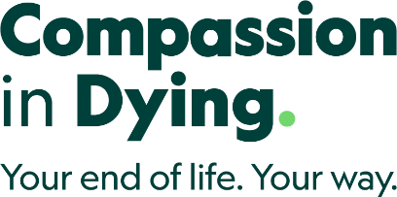

Equal opportunities monitoring information
Dignity in Dying and Compassion in Dying value diversity and work to advance equality. We encourage and welcome applicants from all sections of society. We ask applicants to complete and return an equal opportunities monitoring form with their application, to help us check the effectiveness of our recruitment and equality and diversity policies.
This information will be treated confidentially and will be separated from your application on receipt. This information will not form part of your application and will not be seen by the panel shortlisting or interviewing applicants.
If you choose not to complete this form, your application will not be affected. You may also send this form in separately should you wish.
Name
Please choose one option from each of the sections listed below and then tick the appropriate box.

Your age
years months

Your gender
Female
Male
Non-binary
Other
Prefer not to say

Is your gender identity the same as the gender you were originally assigned at birth?
Yes
No
Prefer not to say

Your ethnic group (options are listed alphabetically)
Asian or Asian British
Indian
Pakistani
Bangladeshi
Any other Asian background, (specify if you wish)

Black or Black British
Caribbean
African
Any other Black background, (specify if you wish)

Chinese or other Asian ethnic group
Chinese
Any other Asian ethnic background, (specify if you wish)

Mixed
White and Asian
White and Black African
White and Black Caribbean
Any other mixed background, (specify if you wish)

White
British
Irish
Gypsy or traveller Any other white background, (specify if you wish)

Religion or belief
Which group below do you most identify with?
No religion
Bahai
Buddhist
Christian
Jain
Jewish
Hindu
Muslim
Sikh
Other, please state
Prefer not to say

Sexual orientation
Please indicate whether any of the following apply to you.
Asexual
Bisexual
Gay man
Gay woman/lesbian
Heterosexual
Pansexual
Other
Prefer not to say

Disability
Do you consider yourself to have a disability, impairment health condition or learning difference?
Yes
No
Unsure
Please describe your disability, impairment or health condition. You may mark one of the boxes below, or use your own words here.

Physical impairment or a condition that affects your mobility such as an impairment that requires you to use a wheelchair or affects arm movement

Sensory impairment, such as being blind/having a serious visual impairment or being deaf/having a serious hearing impairment
Mental health condition, such as depression or schizophrenia
Learning difference such as dyslexia
Learning disability or cognitive impairment such as autism or a head-injury
Long-standing illness or health condition such as cancer, HIV, diabetes, chronic heart disease, or epilepsy
Other, such as disfigurement (please specify)

